|  |  |
| --- | --- |
| Bus Communication with Internal Memory.  9th October 2019.  Prof Randall Brouwer | Daniel Ackuaku |

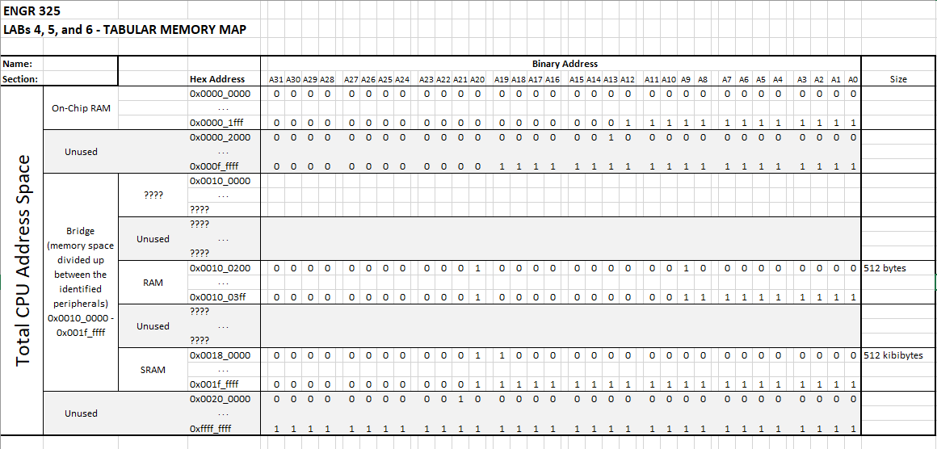

Figure 1 An image of the Lab456AddressMap.xlsx file

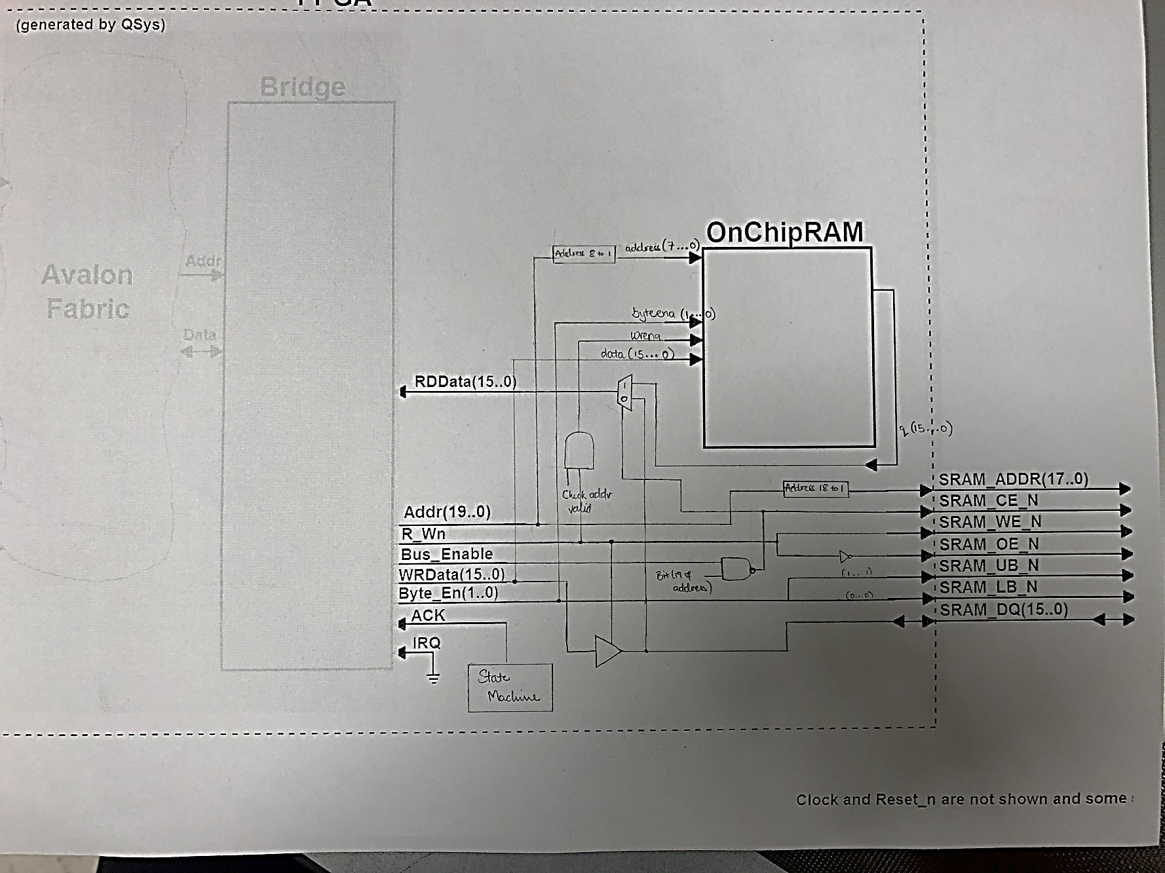

Figure 2 A copy of the block diagram and state diagram.

VHDL CODE for Part A

LIBRARY ieee;

USE ieee.std_logic_1164.ALL;

USE ieee.std_logic_unsigned.ALL;

ENTITY Lab5 IS

PORT (

CLOCK_50 : IN STD_LOGIC;

KEY : IN STD_LOGIC_VECTOR(0 DOWNTO 0);

SRAM_ADDR : OUT STD_LOGIC_VECTOR(17 DOWNTO 0);

SRAM_DQ : INOUT STD_LOGIC_VECTOR(15 DOWNTO 0);

SRAM_WE_N : OUT STD_LOGIC;

SRAM_OE_N : OUT STD_LOGIC;

SRAM_UB_N : OUT STD_LOGIC;

SRAM_LB_N : OUT STD_LOGIC;

SRAM_CE_N : OUT STD_LOGIC;

BUS_EN : OUT STD_LOGIC

);

END Lab5;

ARCHITECTURE Lab5_rtl OF Lab5 IS

-------------------------------------------------------------------------

-- Signal definitions

-------------------------------------------------------------------------

type State_type IS (S1,S2,S3,S4);

signal y_present, y_next : State_type;

Signal ACK_sig : STD_LOGIC;

Signal IRQ_sig : STD_LOGIC;

Signal Bridge_address_sig : STD_LOGIC_VECTOR(19 DOWNTO 0);

Signal Bridge_bus_enable_sig : STD_LOGIC;

Signal Bridge_byte_enable_sig : STD_LOGIC_VECTOR(1 DOWNTO 0);

Signal Bridge_rw_sig : STD_LOGIC;

Signal Bridge_write_data_sig : STD_LOGIC_VECTOR(15 DOWNTO 0);

Signal Bridge_read_data_sig : STD_LOGIC_VECTOR(15 DOWNTO 0);

Signal q_signal : STD_LOGIC_VECTOR(15 DOWNTO 0);

Signal wren_signal : STD_LOGIC;

Signal wren_check : STD_LOGIC;

component nios_system is

port (

clk_clk : in std_logic := 'X'; -- clk

reset_reset_n : in std_logic := 'X'; -- reset_n

bridge_acknowledge : in std_logic := 'X'; -- acknowledge

bridge_irq : in std_logic := 'X'; -- irq

bridge_address : out std_logic_vector(19 downto 0); -- address

bridge_bus_enable : out std_logic; -- bus_enable

bridge_byte_enable : out std_logic_vector(1 downto 0); -- byte_enable

bridge_rw : out std_logic; -- rw

bridge_write_data : out std_logic_vector(15 downto 0); -- write_data

bridge_read_data : in std_logic_vector(15 downto 0) := (others => 'X')

-- read_data

);

end component nios_system;

component OnChipRAM

PORT(

address : IN STD_LOGIC_VECTOR (7 DOWNTO 0);

byteena : IN STD_LOGIC_VECTOR (1 DOWNTO 0) := (OTHERS => '1');

clock : IN STD_LOGIC := '1';

data : IN STD_LOGIC_VECTOR (15 DOWNTO 0);

wren : IN STD_LOGIC ;

q : OUT STD_LOGIC_VECTOR (15 DOWNTO 0)

);

end component;

BEGIN

-------------------------------------------------------------------------

-- Signal assigingments

-------------------------------------------------------------------------

SRAM_ADDR <= Bridge_address_sig(18 downto 1);

SRAM_WE_N <= Bridge_rw_sig;

SRAM_OE_N <= not Bridge_rw_sig;

SRAM_UB_N <= not Bridge_byte_enable_sig(1);

SRAM_LB_N <= not Bridge_byte_enable_sig(0);

SRAM_CE_N <= not (Bridge_bus_enable_sig AND Bridge_address_sig(19)) ;

wren_signal <= ( (NOT Bridge_rw_sig) AND wren_check);

wren_check <= '1' when (Bridge_address_sig(19 downto 9)

= "0000000001") else '0';

-- tri-state buffer for write data

SRAM_DQ <= Bridge_write_data_sig when Bridge_rw_sig = '0'

else (others =>'Z'); --"ZZZZZZZZZZZZZZZZ";

u0 : component nios_system

port map (

clk_clk => CLOCK_50, -- clk.clk

reset_reset_n => KEY(0), -- reset.reset_n

bridge_acknowledge => ACK_sig, -- bridge.acknowledge

bridge_irq => IRQ_sig, -- .irq

bridge_address => Bridge_address_sig, -- .address

bridge_bus_enable => Bridge_bus_enable_sig, -- .bus_enable

bridge_byte_enable => Bridge_byte_enable_sig, -- .byte_enable

bridge_rw => Bridge_rw_sig, -- .rw

bridge_write_data => Bridge_write_data_sig, -- .write_data

bridge_read_data => Bridge_read_data_sig -- .read_data

);

OnChipRAM_inst : OnChipRAM

PORT MAP (

address => Bridge_address_sig(8 downto 1),

byteena => Bridge_byte_enable_sig,

clock => CLOCK_50,

data => Bridge_write_data_sig,

wren => wren_signal,

q => q_signal

);

----------------------------------------------------------------------------

-- MUX for the Read data conditions

----------------------------------------------------------------------------

Bridge_read_data_sig <= SRAM_DQ when (Bridge_bus_enable_sig NAND Bridge_address_sig(19)) = '0' else q_signal;

-----------------------------------------------------------------------------

-- State machine process for the acknowledge

-----------------------------------------------------------------------------

process (Bridge_bus_enable_sig, y_present) is

BEGIN

CASE y_present IS

WHEN S1 => --State1

if (Bridge_bus_enable_sig = '1') then

ACK_sig <= '0';

y_next <= S2;

else

ACK_sig <= '0';

y_next <= S1;

end if;

WHEN S2 => --State2

ACK_sig <= '0';

y_next <= S3;

WHEN S3 => --State3

ACK_sig <= '1';

y_next <= S4;

WHEN S4 => --State4

ACK_sig <= '0';

y_next <= S1;

END CASE;

end process;

process (CLOCK_50, KEY(0))

BEGIN

if (KEY(0) = '0') then

y_present <= S1;

elsif (CLOCK_50' EVENT AND CLOCK_50 = '1') then

y_present <= y_next;

end if;

end process;

IRQ_sig <= '0';

BUS_EN <= Bridge_bus_enable_sig;

END Lab5_rtl;

------------------------------------------------------------------------------------------------------------------------------------------

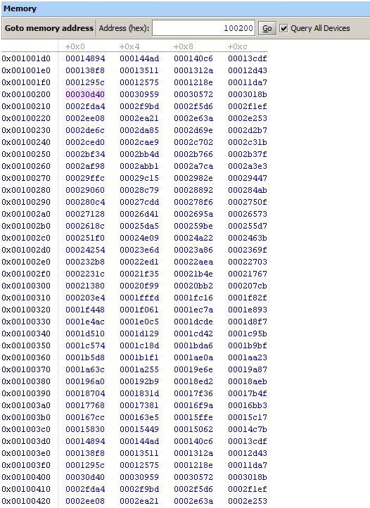

Figure . Data being written into the RAM.

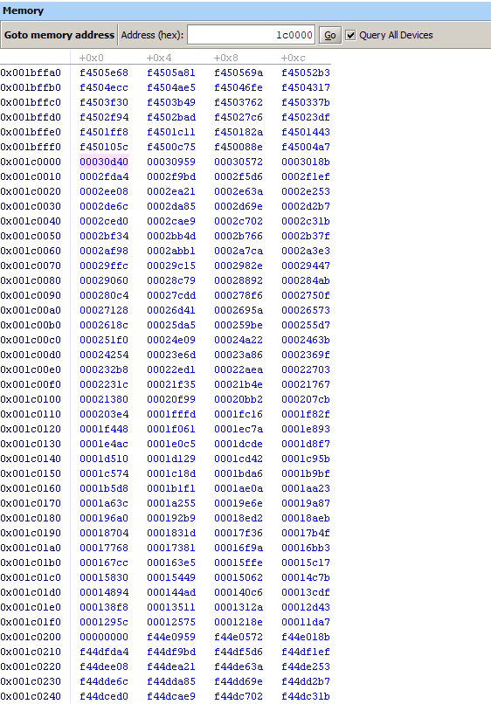

Figure . Data read from RAM being written into the SRAM

C code foreading and writing to the RAM

#include <io.h>

#include "busbridgehal.h"

int main() {

unsigned int SRAMbase; // SRAM base address

unsigned int OnChipRAMbase;

unsigned int mem_point; unsigned int mem_fill;

OnChipRAMbase = 0x100200;

// code that exercises the off-chip SRAM

writeBusIO(4, OnChipRAMbase, 0x00, 0x87654321);

writeBusIO(2, OnChipRAMbase, 0x04, 0x5a78);

writeBusIO(1, OnChipRAMbase, 0x06, 0x3c);

writeBusIO(1, OnChipRAMbase, 0x07, 0x1f);

// add commands to read back the memory using readBusIO() function

readBusIO(1, OnChipRAMbase, 0x00);

readBusIO(1, OnChipRAMbase, 0x01);

readBusIO(2, OnChipRAMbase, 0x02);

readBusIO(4, OnChipRAMbase, 0x04);

int sub = 999;

mem_fill=200000;

mem_point=0x00;

//

while( mem_point <= 512){

writeBusIO(4, OnChipRAMbase, mem_point, mem_fill);

mem_fill = mem_fill-sub;

mem_point += 0x04;

}

SRAMbase = 0x1c0000;

int readPointer = 0x00;

int read;

while (readPointer < 512){

read = readBusIO(4, OnChipRAMbase, readPointer);

writeBusIO(4, SRAMbase, readPointer, read);

readPointer += 0x04;

}

return 0;

}

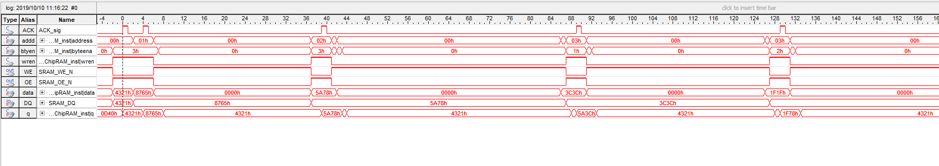

Figure . Signal tap for writes.

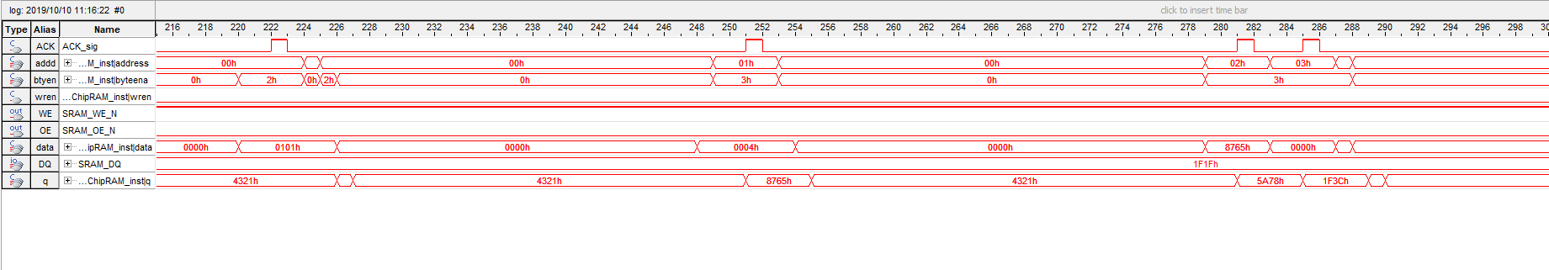

Figure . Signal tap for reads